

Name | M. Ayaz Rafique
ID No | 241925
Subject | Full Stack Lab
Lab No | 02
Date | 19th-Sept-2026

Lab Task # 01
Registration Form:
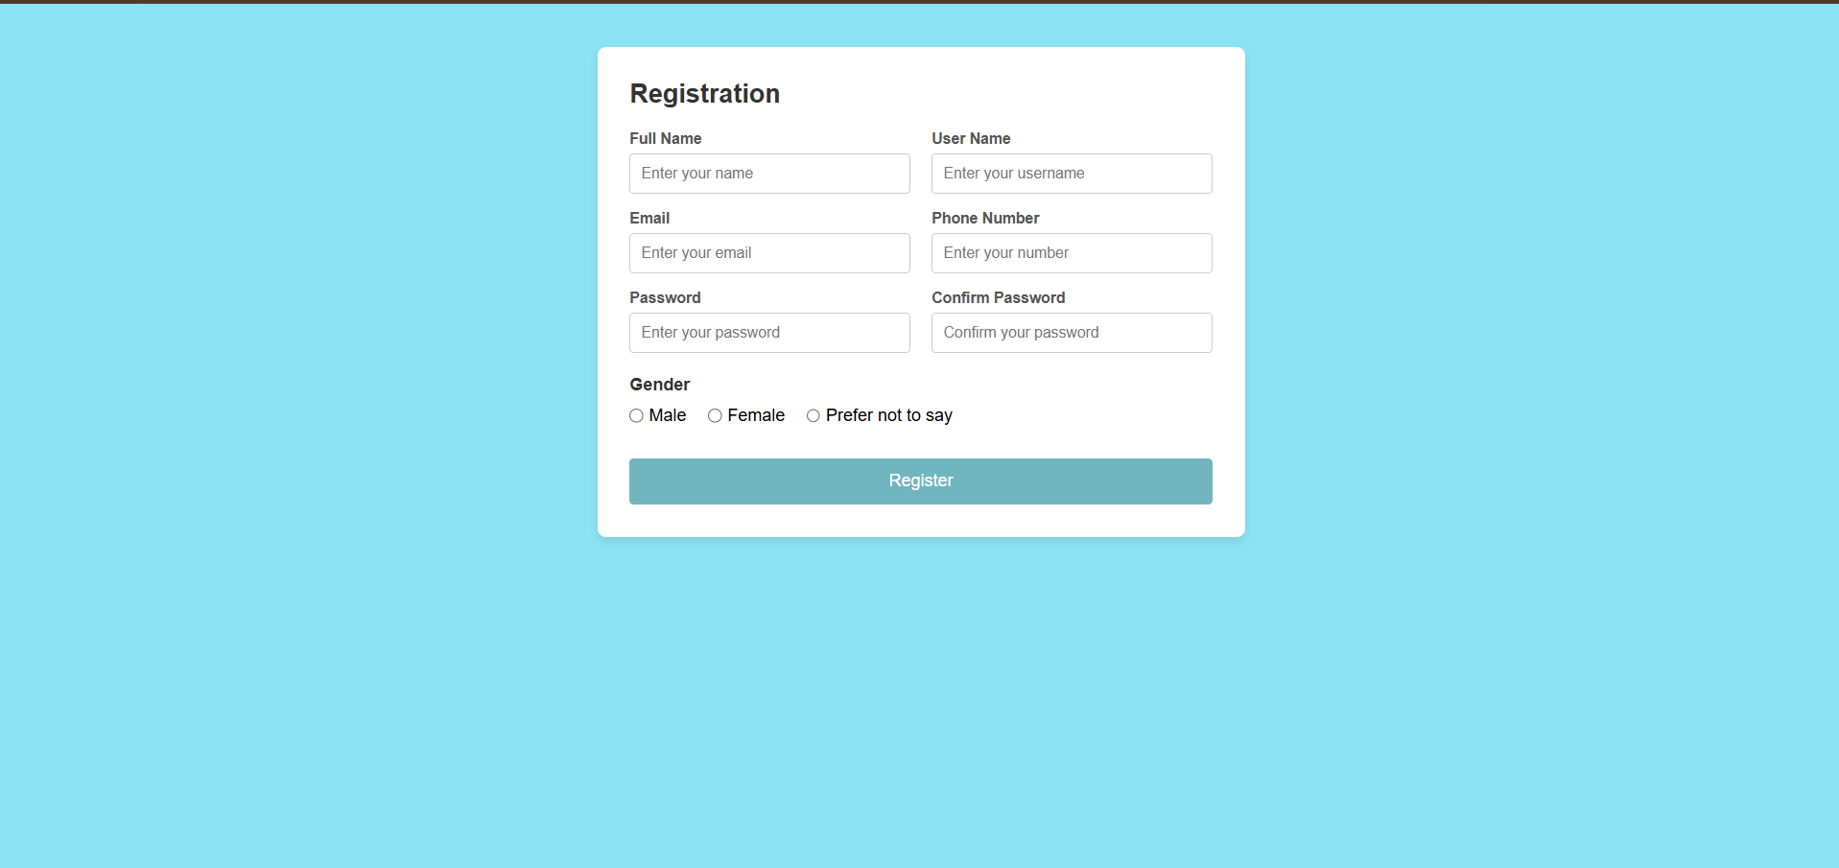

Lab Task # 02 :
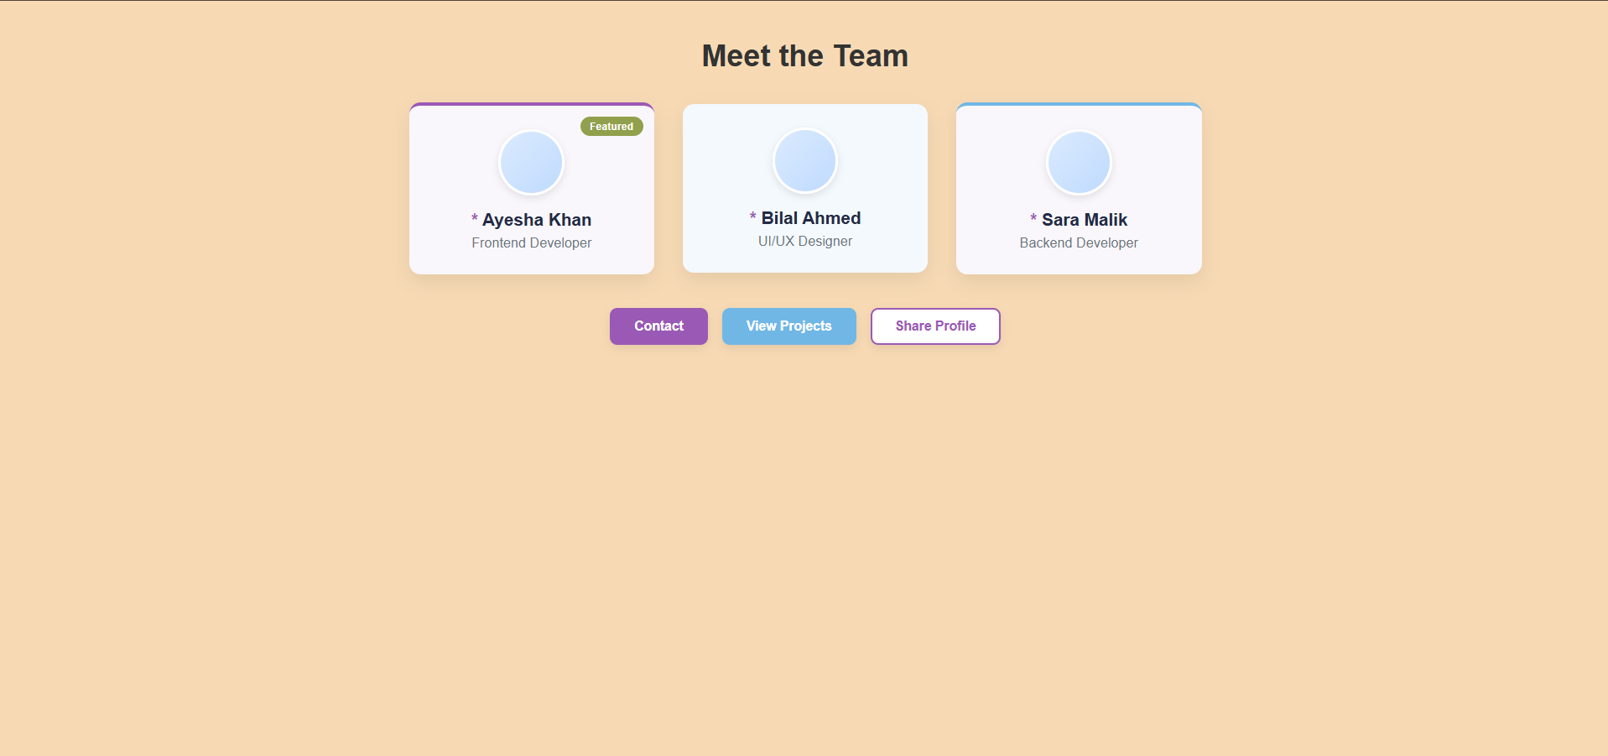

Home Task
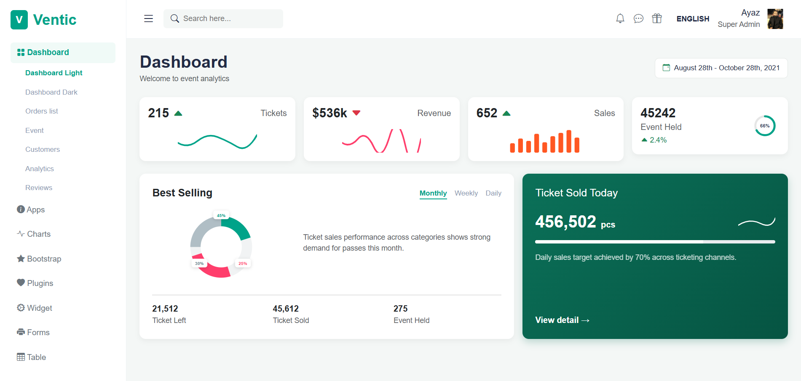

Task 1 – Responsive Registration Form
I created a clean and responsive registration form using HTML and CSS Flexbox. The form includes fields for personal information, password confirmation and gender selection. I also added a full-width register button with hover effects and designed the form as a centered card with rounded corners and a soft shadow.
Task 2 – Interactive Team Showcase
I developed a responsive team showcase with profile cards for different team members. The cards automatically adjust to different screen sizes using Flexbox. I also added profile images, featured badges, colored borders, and interactive buttons such as Contact, View Projects, and Share Profile. CSS pseudo-elements and pseudo-classes were used to improve the overall design.
Task 3 – Ventic Event Analytics Dashboard
For the home task, I created an event management and ticketing dashboard inspired by the Ventic design. It includes a sidebar navigation, search bar, notifications, user profile area, and different analytics cards. The dashboard displays ticket sales, revenue, performance statistics, charts, and ticket progress in a visually organized way.

